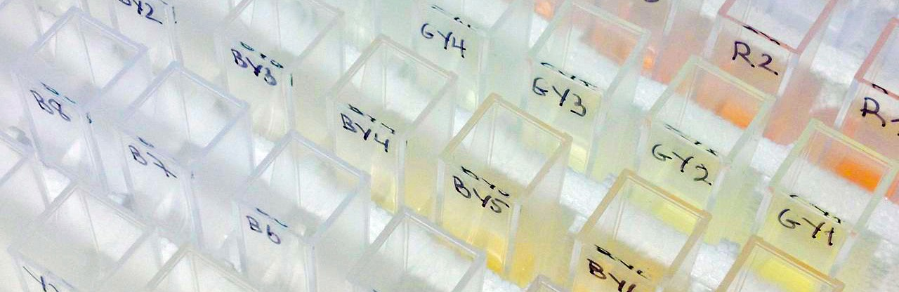
MM 5254
Measurement Method

Validation of the EP European Pharmacopoeia Color Scale

ABSTRACT

“When a pharmaceutical company asks how they can validate the implementation of HunterLab EasyMatch QC+ER software for EP Color, the expectation is that all 37 EP Colors will read and display their assigned EP color rating.”
EP Color is used typically in the pharmaceutical industry to assign a color rating to liquid samples indicative of their product quality.

The original intent of using EP Color was to improve color communication over more ambiguous
word descriptors such as ‘slightly yellow” by visual comparison to a fixed set of 37 transparent EP liquid color standards, all of which are yellow.



As defined in European Pharmacopoeia Method 2.2.2, the visual EP Color Scale consists of 3 primary color standard solutions (yellow, red and blue) combined with a dilute hydrochloric acid solution to make 5 standard color solutions - B (brown), BY (brownish-yellow), Y (yellow), GY (greenish-yellow) and R (red) that are subsequently diluted with hydrochloric acid (10 g/l HCl) to make 37 reference EP liquid color standards - 9B, 7BY, 7Y, 7GY and 7R.

An increase in yellowness can be a quality indicator of:
- Degradation over time in shelf life studies
- Presence of impurity
- Process change or variation
- Inconsistency in incoming components that leads to variation in the final product
CIE 15:2004 Colorimetry and USP Monograph 1061 define tristimulus color measurement system that can represent any perceived color with three numbers – typically CIE L*, a* b* color values. For any color,
L* represents relative lightness; a* represents redness-greenness; and b* represents blueness-yellowness. Tristimulus color measurement can be used to correlate to the visual European Pharmacopeia color standards. This has been done by HunterLab and implemented in our software.
EP Color measurement can be used to verify color quality in liquid APIs and excipients, concentrated liquid proteins or any liquid that tends to become yellow at the raw material, intermediate and final product stages.

Validation Requirements
When a pharmaceutical company asks how they can validate the implementation of HunterLab EZMQC+ER software for EP Color, the expectation is that all 37 EP Colors will read and display their assigned EP color rating. This is a reasonable requirement but requires further definition of three test parameters for the validation protocol.
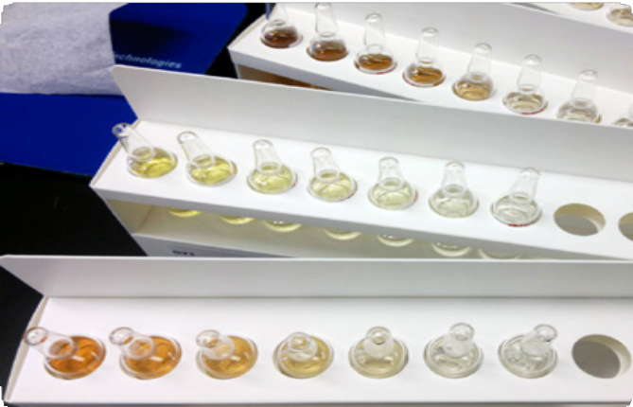
- Source for the visual EP liquid Color Standards - There is an assumption that all EP Color Standards are exactly the same color if formulated following the European Pharmacopoeia Method 2.2.2 method. This may be true for the original intended use of EP color for visual color evaluation but instrumental color measurement is more precise and able to discern several time finer than human visual evaluation. For instrumental validation it is essential to define the target clearly. European Pharmacopoeia Method 2.2.2 provides no advice on this but it has been our experience that EP Colors from multiple sources vary slightly in color even if they all meet the EP Method 2.2.2 formulation.

For this validation protocol, purchase a set of liquid EP Color standards from Fluka Analytical of Sigma Aldrich (www.sigmaaldrich.com). One can search on
Figure1. The 10 ml full set of EP liquid color standards from Fluka Analyitical of Sigma Aldrich www.sigmaaldrich.com

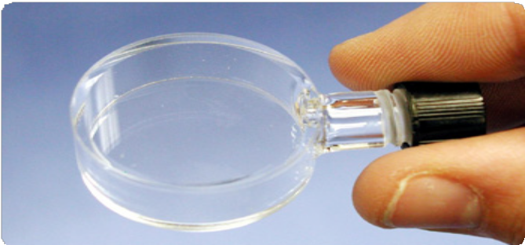
“Pharm Calibration Standards”, then select “Ph Eur Color Standards”). The 10 ml set will be needed for this validation.

- Use of the A13-1011-613 10mm Round Cell and d02-1011-886 Cell holder - While other 10mm path length cell options can be used to measure EP Color in samples, it is important for EP Color Validation, that a cell option be used that does not compromise the optical performance of the instrument. All HunterLab sphere instruments have a near-collimated light path of 17mm diameter across the transmittance compartment. To balance the need for minimal sample volumes combined with optimal color measurement performance of the instrument, the A13-1011-613 Round Cell and D02-1011-886 Cell Holder is designated as the sole cell option for EP Color Validation. This cell has a 10 mm path length while just covering the optical light path within the 25 mm diameter TTRAN (Total Transmittance) port.
Measuring at the TTRAN port with this cell can also be used to validate EP Opalescence.

- Report EP Color Values to Whole numbers - Instrumental measurement has sufficient precision to allow the reporting of EP Color to a tenth of a unit such as “EP Y3.1”. However, in keeping with the origins of the original visual comparison test, this EP Color Validation process is specifically limited to reporting EP Color in whole values such as “EP Y3”.

A13-1011-613 Small Volume (4 ml) Transmittance Cell with 10mm path length. More information at http://wp.me/p24zt3uW
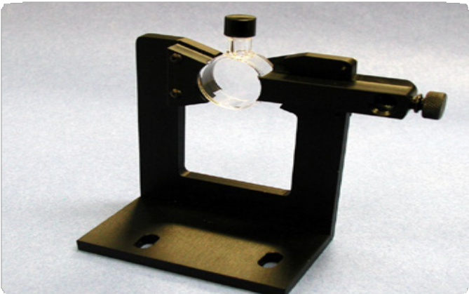
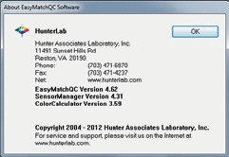
A13-1011-613 Small Volume Transmittance Cell in D02- 1011-886 Transmittance Cell Holder

Measurement Method For EP Color Validation
Here is a step-by-step protocol for validating EP Color measurement in Transmittance using EasyMatch QC software with a HunterLab UltraScan VIS or UltraScan PRO spectrophotometer.
- First verify that you have the EP 10 mm Color Index installed in you software. Start EasyMatch QC and select HELP > ABOUT. Verify that the EasyMatch QC+ER version is 4.62 or higher. If not, contact HunterLab.


- In the transmittance compartment, install the
D02-1011-886 Transmittance Cell Holder such that it is centered at the TTRAN (Total Transmittance) port.

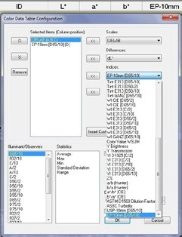
- In an EasyMatch QC job, put your mouse over the COLOR DATA VIEW > RIGHT CLICK > CONFIGURE, then select CIE L*, a*, b* D65/10 as a full color scale display and EP-10mm [D65/10] as an index in the Color Data view.

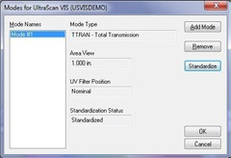
- EP Color is measured on a sphere instrument such as like the UltraScan VIS or UltraScan PRO. Set up a mode for TTRAN LAV UV Filter Nominal transmittance and standardize the sensor in this mode using the Light Blocker to set 0% transmittance and A13-1011- 613 Small Volume Transmittance Cell (10 mm path length; 4 ml volume) filled with distilled water in the D02-1011-886 Transmittance Cell Holder to set 100% transmittance (instrument white tile will cover the reflectance port).
- As a PQ (Performance Qualification) step read back the cell filled with distilled water with a reading of L* = 100.0, a* = 0.0, b* = 0.0 D65/10 and EP-10mm [D65/10] Color = Water expected to be displayed.

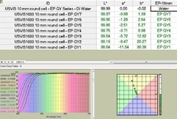
- Fill the Small Volume 10mm cell with each of the liquid EP color standards such as the Green-Yellow Series, taking a single reading of each.

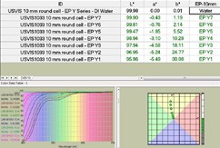
- Read the EP Yellow Series. All series radiate out from DI Water.

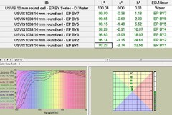
- Read the EP Brown-Yellow Series with the following expected results.

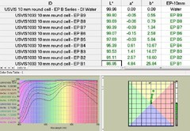

- Read the EP Red Series with the following expected results.

Conclusion
If all EP Color standards read as assigned, EasyMatch QC+ER software is considered validated.
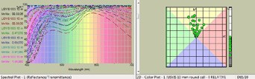

References
Reference for EP Color Standards: European Pharmacopoeia Method 2.2.2 Degree of Coloration of Liquids, European Pharmacopoeia, Strasbourg, France (1997: 15-16) www.pheur.org.

About Hunterlab
HunterLab, the first name in color measurement, provides ruggedly dependable, consistently accurate, and cost effective color measurement solutions. With over 6 decades of experience in more than 65 countries, HunterLab applies leading edge technology to measure and communicate color simply and effectively. The company offers both diffuse/8° and a complete line of true 45º/0º optical geometry instruments in portable, bench-top and production in-line configurations. HunterLab, the world’s true measure of color.

© Hunterlab 11/2023

